
Xiamen International School After-School Program
1st Trimester 2013-2014
Welcome to the After School Program (ASP) at Xiamen International School. This extensive program of studies offers enhanced learning in the visual arts, performing arts, athletics and academics. Teachers volunteer their after school time to further engage students in their interests and create fun, exciting and meaningful learning experiences. Please reflect with your child about what values these ASP's might offer and also have created in the past for both you as individuals and the XIS community at large.
Safety is a number one priority. As transportation is arranged and pick up times are communicated, students will need to follow through with attendance at their choosen ASP class, so that the parents can pick up their child in a timely manner without problems. A teacher/coach will supervise them until the late bus arrives at XIS to take everyone home. If your child is sick, you may receive a phone call from our nurse for early pick up. Illness is the only reason for not attending an ASP.
Please note that a special late bus will be added this year for the Upper School Athletic teams for a longer practice time and to facilitate the increasingly different schedules of Athletics (W & F, 3:30 to 5:15) and ASP's.
欢迎来到厦门国际学校课外活动（ASP）项目，这一拓展学习项目为学生们提供了在视觉艺术，表演艺术，体育运动以及课业学习上辅助加强学习的机会。老师们利用他们的课后时间进一步激发学生的兴趣爱好，创造充满趣味性的、有意义的学习体验。请与您的孩子讨论这些ASP课外活动项目的学习价值，以及过去这些ASP项目给予你们个人和XIS带来的收获。
安全是最重要的。由于校车和家长的接送时间已经安排敲定，学生们必须按时参加选定的ASP课程，这样放学后，家长才能顺利按时接到他们的孩子。在晚班校车到达XIS前，教师/教练将监督指导学生。如果您的孩子在上课期间生病，校保健室人员将致电给你们，请你们提前来接学生回家。除非病假，学生不能缺席所选的ASP课程。
请注意，学校将提供一辆特别的晚班校车来接送中学部联赛校队学生，让学生们可以有更长的训练时间，方便校队训练和ASP课外活动项目的时间安排。
有问题吗？请联系Douglas "Wei Lao Shr" Ward厦门国际学校体育组组长邮箱：douglasward@xischina.com.cn
샤먼국제학교 방과후 프로그램 (ASP)에 오신 것을 환영합니다. 이 프로그램은 여러 분야에서 학생들이 긍정적으로 성장, 발달할 수 있도록 시각예술, 자기표현, 체육운동 등을 제공합니다. 교사와 학생 모두 학습 내용으로 재미있고 흥미로운 체험학습에 직 접 참여하고 활동할 것입니다. 여러분의 자녀와 함께 방과후 프로그램(ASP) 가치에 대해 의논하시기 바랍니다.
학교에서 무엇보다 학생들의 안전이 최우선입니다. 학생 운송버스 승·하차 스케줄이 정해졌으므로, 학생들은 반드시 선택한 ASP에 참가해야 합니다. XIS에 버스가 도착할 때까지 교사/코치가 학생들을 지도할 것입니다. 만약 여러분의 자녀가 아플 경우, 학 교 간호사가 부모님께 전화로 연락할 것입니다. 학생들은 질병외에 반드시 ASP에 참 석해야 합니다.
학교에서는 고학년 선수들의 훈련시간 연장과 다양한 방과후 활동 스케줄을 배정하기 위해 특별히 운송버스(late bus) 1대를 추가로 제공할 것이므로 유의하시기 바랍니다.
문의사항은 XIS체육담당 Douglas "Wei Lao Shi" Ward, douglasward@xischina.cn. com로 연락주시기 바랍니다.
XIS After-School Program

Trimester 1, 2013-2014
September 10th to Nov. 20
Elementary School

Diamond Sports!
Grades 3-5
Mr. Hill & Ms Purdy
Learn the rules for popular Diamond sports such as kickball, baseball and more! Learn base running, innings, outs, scores, and of course home runs. If you already know the basics, don't worry we will also work on developing better kicking, running, sliding, batting, and throwing techniques. And most of all just come for fun! Mr. Hill and Ms Purdy will lead us in this very popular ASP.
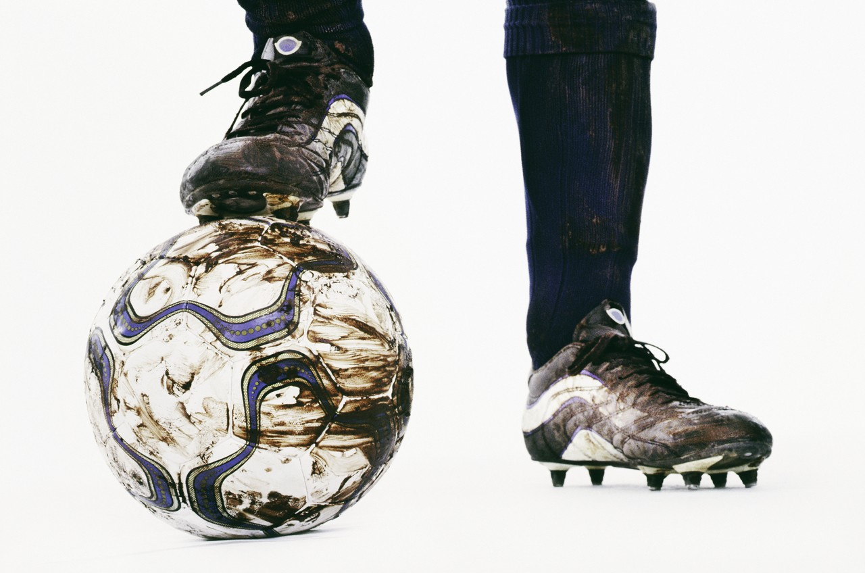
Soccer!
Grades 4-5
Mr. Ward & Mr. Lugang
The most famous sport of the modern world is back to XIS in the Lower school. This year we will work more on our short passing and control game. Also, we will have short sided games and many ball control games. You will continue to improve through multiple touches and teamwork. If we are lucky, we may have a tournament at the end of the season…. Go Dolphins! Mr. Ward and other XIS coaches will lead.

Mad Science Club grades 2-4
Ms. Wilson
Come and explore the mysteries of science. This ASP is taught by our High School mad scientist Ms Wilson. Ms Wilson is an IB Chemistry teacher with years of experience making ghoulish science experiments.
Surf and Turf! Grades 3-6
Ms. Lee & Ms. Kristoff
This ASP will begin in the pool, where we will work on swim strokes, have speed trials, and play water games. Students must be able to swim one length to join. The end of our ASP will be field games to build strength and stamina.
Drama Exploration: Grades 1- 5
Ms. Brooker & Ms. Brown
Students will have the opportunity to explore drama related activities. These will include improvisation, role play, exploring emotions and body movements, miming and more. Students will develop confidence as they collaborate and express themselves through drama. During this ASP, students may be grouped as a whole or work in smaller group. Elaine Brooker and Katherine Brown will lead us in this ever popular ASP.
Gamers Table Grades 3-5:
Ms. Johnson
Welcome to the golden age of board gaming! At the Gamers Table you and your friends (or arch rivals) will have a chance to match deductive, diplomatic, and strategic powers as you battle for supremacy with a wide variety of modern designed board and card games. Don't like heavy competition? There will also be a good selection of cooperative and pure fun games. See Esther Johnson for details, and we'll see you at the Gamers Table!


Mandarin Club: Grades 3-5
Ms. Joy & Ms. Kim
Mandarin teachers Ms Joy Wang and Ms Susan Kim will host the "Mandarin Club" ASP for Session 1. Activities include: Chinese Qiqiaoban, paper folding, Chinese chess and calligraphy. This is a great way to learn about one of the oldest and most amazing cultures of the world. Fun, Fun, Fun!

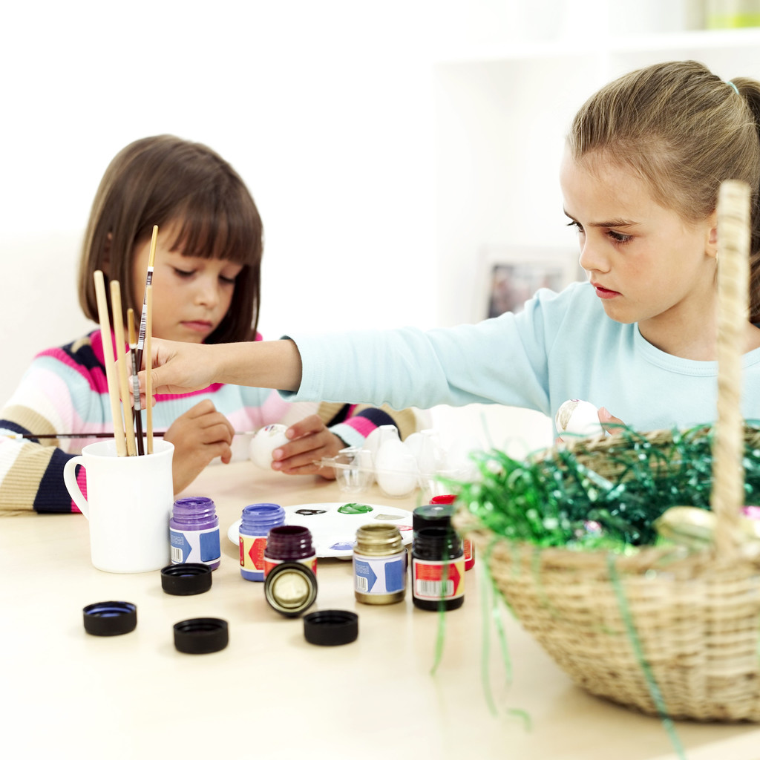
Mural Painting!
Grades 4-5
Ms Wu Li & Ms Flora
Ms Wu Li and Ms Flora are going to hold a mural painting ASP for G4 and G5 students in First Trimester.

Storybook Arts: Grades 2-3
Ms. Fleck & Ms. Studendorf
Do you enjoy reading and art? Come to Storybook Art and get a little of both. Have fun with exciting stories and bring your imagination for a colorful piece of art to go with each story.

Math Lab ASP: Grades 3-5
Mr. Dennis
Do you like to play math games on the computer? Do you want to explore different math websites and learn how solve puzzles? Do you want to see how math is used in different areas subjects like art, music and in science? Sign up for Math Lab. We will explore math games and topics using the IT Lab. This ASP is open to students in Grades 3 – 5. Mr. Dennis is our XIS grade 5 teacher.

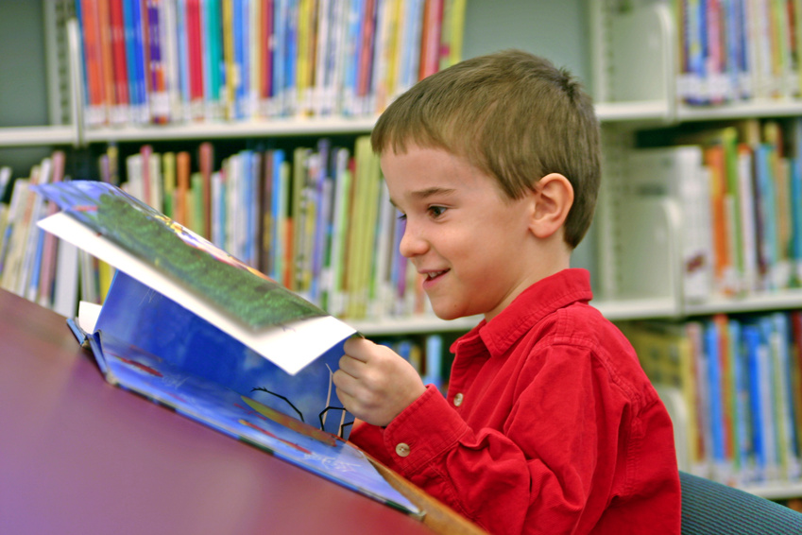
Read to Succeed: Grades 3-5
Ms. Cronk & Ms. Castle
Read to Succeed. Snuggle up and read in the library! Bring your favorite stuffie and enjoy reading in the library after school. You can relax in the chairs or curl up under a desk. Explore any books in the library and you can even read to a friend. See you in the library!

Grade 1 ASP
Music, Motion and Games
Ms. Bisbey
(Maximum number: 15)

Students will partcipate in a range of activities focusing on exercise, group cooperation, and music. Games may include kickball, duck duck goose, bop, farmer and the rabbit, silent ball, red light green light, freeze tag, and many more. Students will also sing and do motions to songs in English and Chinese.

